Tender reference No: IIESTS/CE/GTE/2021-22/LOADING FRAME -01 Date: 31.03.2022

NOTICE INVITING TENDER

Sealed tenders are invited by the Civil Engineering Department, Indian Institute of Engineering Science and Technology, Shibpur, Howrah-711103 for the supply of Loading Frame in Physical Modelling Laboratory, Department of Civil Engineering, Indian Institute of Engineering Science and Technology (IIEST), Shibpur.
Tender Documents containing details of the items and terms and conditions may be downloaded from the institute website and completed bidding documents are to be submitted to the Head, Department of Civil Engineering, Indian Institute of Engineering Science and Technology, Shibpur; Howrah-711103 or dropped into the Tender Box kept in the Department within April 14, 2022 (4:00 pm).
For further clarification, please contact Dr. Ambarish Ghosh (9831286527).
Enclosed: Section- I: General Conditions and Important Instructions for Bidders.
Section-II: Detailed Specification of the Loading Frame.

Head
Department of Civil Engineering
IIEST, Shibpur

SECTION-I: General Conditions and Important Instructions for Bidders
- Interested parties/vendors are to download the tender documents with detailed specifications from the institute website (www.iiests.ac.in)
- It is necessary to submit the original tender documents along with technical and price bids to the Office, Department of Civil Engineering, Indian Institute of Engineering Science and Technology (IIEST), Shibpur; Howrah-711103.
- Bidders are to abide by the terms and condition and submit this tender document in original duly signed with acceptance of the terms and conditions.
- Last date of receipt of tender is April 14, 2022 (4:00 pm). Tenders received late will not be accepted under any circumstances. Tenders will be opened in the Department of Civil Engineering, on the same day at 4:15 pm. In case the Institute remains closed on the said date, tenders will be opened on next working day at 4:00 pm.
- The Price Bid should clearly mention the price including the following:
  - Delivery charges up to Physical Modelling Laboratory, Department of Civil Engineering, IIEST, Shibpur, Howrah, including loading and unloading charges.
  - All taxes, duties, levies applicable.
  - Erection, Commissioning and testing charges at Physical Modelling Laboratory, Department of Civil Engineering, IIEST, Shibpur site
- DGS&D rate contract price will be preferred wherever applicable. The Institute will not issue any C or D form availing for concessional Sales Tax/ VAT. The Institute will issue Customs Duty Exemption Certificate or Excise Duty Exemption Certificate for foreign purchase, if required.
- The equipment/goods are to be supplied at the Physical Modelling Laboratory, Department of Civil Engineering, Indian Institute of Engineering Science and Technology between 11.00 am and 4.00 pm from Monday to Friday except holidays. The bidders will be responsible for any breakage, damage or defect in the equipment detected subsequently.
- Period of delivery of equipment/ execution of work should be within two week from the date of issue of Purchase Order. If the supply/execution is not completed within the stipulated period as indicated in the Purchase Order a Liquidated Damage @0.5% per week will be imposed on the value of purchase order.
- Concessional GST @5% is applicable for our Institute. Necessary documents will be issued with the purchase order to the qualified bidder.
- .
- Bills in triplicate should be presented for payment within 7 days of supply/ commissioning of work. No advance is paid for execution of the order. The Order No. is to be noted on both Challan and Bill. All bills are to be accompanied by order copies and Challan receipt.
- Payment will be made on submission of Proper Bills, Challans etc, by A/C Payee Cheque and no cash payment will be made under any circumstances.
- All payments are subjected to statutory deductions as and when applicable.
- Tender is to be kept valid for acceptance for 3 months with effect from the last date of issue of the tender without any modifications in its terms and conditions.
- Documents mandatory to be submitted with the tender:
- Tender Documents, General Conditions and Important Instruction in original duly signed by the Proprietor/ Partner/ Director of the company as a token of acceptance of Terms and Conditions of Tender.
- Latest Income Tax, Sales Tax, Professional Tax clearance certificates and copy of valid Trade License
- Bid according to specifications.
- Certificates and Literature in support of the item.
- Authority reserves all rights to accept/reject any/all quotation without showing any reason.

I/We accept the above terms and conditions.

_______________________________
Signature of vendors with date & Seal

Section-II: Detailed Specification of the Loading Frame

- The Loading Frame should include but not limited to all components as mentioned in Table 1 and as shown in Figure 1
- All the Structural members of specified sections mentioned in Table 1 should conform to IS: 226, IS: 808 & SP (6)- 1964.
- The Price Bid should include and clearly mention the price including the following:
- Cost required for delivery, haulage including loading and unloading charges, hoisting, erecting and connecting all the Structural members of specified sections mentioned in Table 1 to one another with bracket, gussets, cleats as per design, complete including cutting to requisite shape and length, fabrication with necessary bolting, metal arc welding conforming to IS: 816- 1969 & IS: 1995 using electrodes of approved make and brand conforming to IS:814- 2004, all complete at Physical Modelling Laboratory, Department of Civil Engineering, IIEST, Shibpur.
- Cost required for procuring all Structural members of specified sections mentioned in Table 1, consumables such as electrodes, gas and hire charge of all tools and plants and labour required for the work including all incidental charges such as electricity charges, labour insurance charges etc. all applicable.
- All taxes, duties, levies as applicable.

Table 1: Details of items of loading frame

Sl No | Description of items of work | Measurement of Quantity
 |  | No | L (m) | B (m) | H (m)
1 | For loading Frame
a) | Top Horizontal Beam ISMB 250 (I section) | 1.0 | 2.4384
b) | Tie beam at the Bottom Horizontal Member ISMB 200 (I section) | 1.0 | 3.0480
c) | Vertical support column Members ISMB 250 (I section) | 2.0 | 2.4384
d) | Main inclined member for lateral load frame ISMB 150 (I section) | 1.0 | 2.1336
e) | Smaller members of lateral load frame ISMC 100 (C section) | 1.0 | 2.4384
 | Plates for attaching I and C sections
f) | 12.3 mm thick plate for fixing top horizontal beam to vertical column | 4.0 | 0.2250 | 0.0123 | 0.1000
g) | 12.3 mm thick plate for fixing top vertical column to bottom tie beam | 4.0 | 0.2250 | 0.0123 | 0.1250
h) | Plates for stiffeners of Members to resist local buckling (0.006 m thickness) | 44.0 | 0.0500 | 0.0063 | 0.2250
i) | Stiffeners plates (12.3 mm thick) | 8.0 | 0.2100 | 0.0123 | 0.2100
 | Inclined MS pipes
j) | MS pipes for lateral support (OD 50 mm; Thickness 2.9 mm) | 5.0 | 2.4384
k) | MS plate 150 mm dia; 6.3 mm thick (Flange for MS pipes) | 5.0
 | Arrangement to attach hydraulic jack
l) | Plate for fixing hydraulic jack (Top and bottom) (19 mm thick) | 3.0 | 0.2250 | 0.0190 | 0.2250
m) | I Beam ISMB 250 for fixing hydraulic jack | 1.0 | 1.2192
2 | Stud to hang arrangement to attach hydraulic jack
a) | Stud Bolts with nut and spring washer for fixing hydraulic jack accepting frame (M25 (25.4 mm dia), Length 45 cm) (With bright bar and squared thread) | 4.0 | 0.4500
b) | 25 mm ID bush for stud (With bright bar and squared thread) | 4.0 | 0.0500
3 | Foundation
a) | Concrete floor cutting | 1.0 | 3.0480 | 0.4500 | 0.3000
b) | Concrete of M 25 Grade | 1.0 | 3.0480 | 0.4500 | 0.3000
4 | Anchor bolt
a) | 15 mm dia Nut, bolt and washer for anchoring tie beam to foundation | 4.0 | 0.2500
b) | 12.3 mm dia Nut, bolt and washer for anchoring MS pipes to foundation | 10.0 | 0.1500
5 | Painting with metal primer and synthetic enamel paint on all metal surface
6 | Gas cutting for sizing, drilling, fabrication, irrection, carrying, loading, unloading, etc.

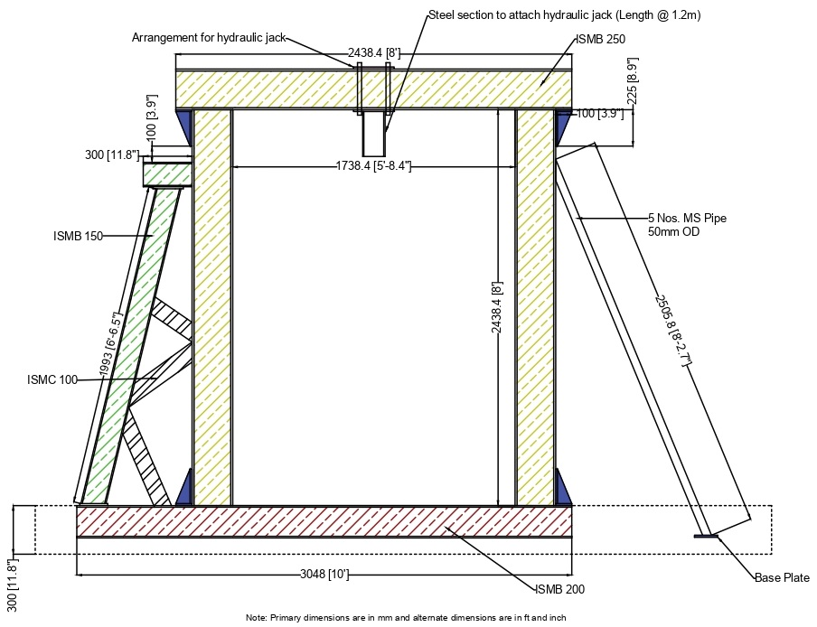

Figure 1. Front view of Loading Frame

